**Lab#08**

Task:01 Create an XML document structuring information for a store. (shopping store of your choice)

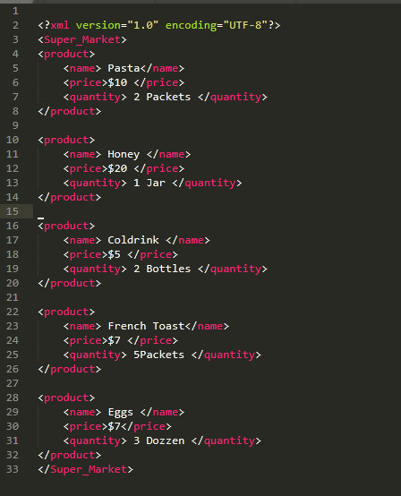

Task:02 Create DTD for store XML Document. And validate.

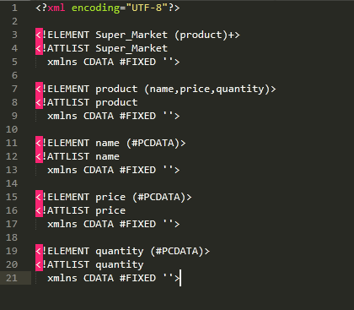

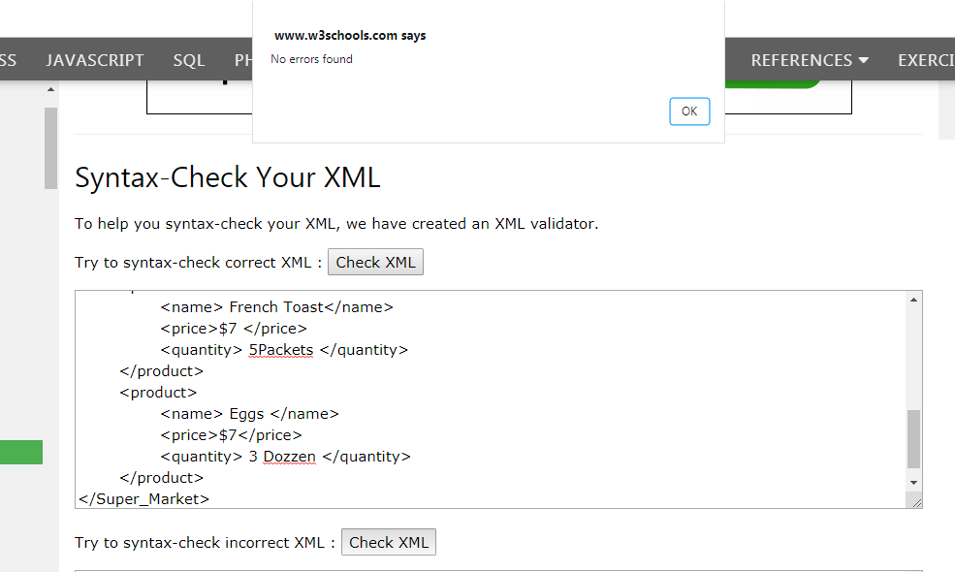

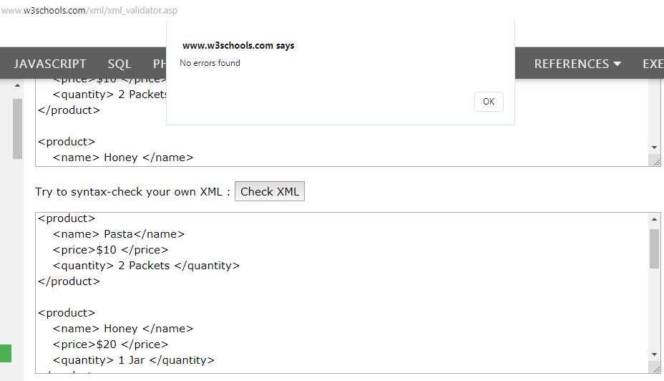

Task:03 Write XML Schema for the following XML document and then validate the XML document along with its schema:

